Git Assignment 1 Answers

1. “git stash list” is a command which is used to list the modifications stashed by the command “git stash”.
2. We can use the command “git diff-tree -r {hash}” to list all the files that were modified in a particular commit. We will get the list of all the individual file modified in a particular commit rather than the root directory name only because of the “-r” flag.
3. One can consider merge conflict as a kind of warning that stops us from merging the side branch into the main branch. This happens when there is some kind of conflict between the existing code in the main branch and the code in the side branch. Whenever git warns us about the merge conflict, us as developers need to pitch in and solve this merge conflict. Solving merge conflict means to just decide whether to keep the conflicting code from main branch or the conflicting code from the side branch.
4. 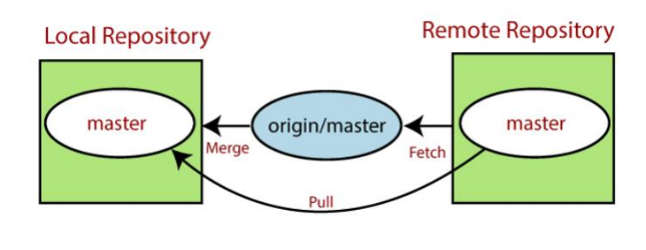Two commands namely “git fetch” and “git pull” are basically used to get the code from the remote repository to the local repository. Git fetch copies the changes in code from the remote repository into the local repository. Git pull copies the changes in code from remote repository to the local repository and also merge those changes into the working directory. So, basically one can say that the git pull command is the combination of git fetch and git merge command.

There are two ways one can add the code from side branch into the main branch. First way is using merging and the second way is using the rebasing operation. There is one fundamental difference between these two operations even though both performs the similar kind of work. While merging all the commits from the side branch are squashed into one commit in the main branch while in rebasing all the commits from the side branch are pasted as it is in the main branch.

Git merge:

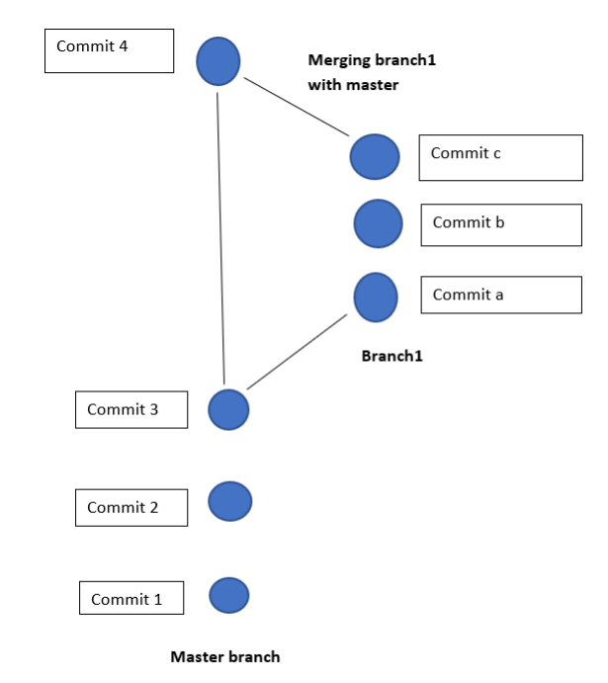

Git rebase:

1. 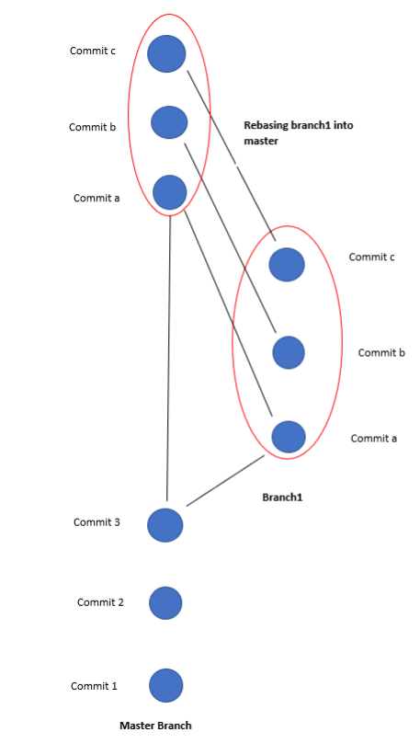We can use “git clone” command to download any GitHub repository to your computer. More precisely you need to use the command “git clone <URL-for-the-GitHub-repository>”.
2. To write commit message while committing the modifications in the code using the flag “-m”.

e.g., git commit -m “your-commit-message”

To push the code to the GitHub, one need to follow the following chain of commands:

1. First add all the changes in the code to the staging area: git add .
2. Commit all the changes in the staging area: git commit -m “your-commit-message”
3. After committing all the changes, you will push the changes to the remote repository such as GitHub using the command “git push origin <GitHub-repository-link>”. The shorthand here used is origin but you should use the one that you have created. Pushing will only work if head of your local repository is ahead of the remote repository. If this is not the case then before pushing to the remote repository, one should first pull the changes from remote repository to the local repository. Generally, first pulling and then pushing from remote repository to the local repository is considered as a good practice.
4. Git repository can be created using “git init” command. This will create empty repository locally in your computer. If you want to create a remote repository and then connect this local repository to the remote repository, then you need to add the remote using the command “git remote add <URL-of-the-remote-repository>”.
5. Git is a version control system for the code. Git works by making use of four places namely working area, staging area, local repository and remote repository. The flow of the code can be understood using the following figures.

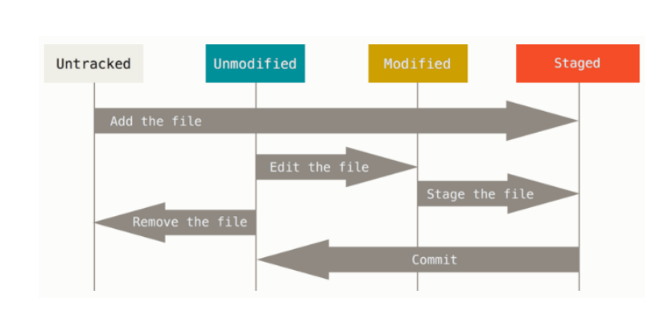Once the change in the code is made, git detects it and ask it to be staged followed by committed. This process allows git to track the changes in the code over time. If you want to track the changes and collaborate over the same code using the team with many personnel the n we have make use of remote repository in such case.